Local Yum Repository

1. Mount the Redhat enterprise linux dvd to /mnt directory-

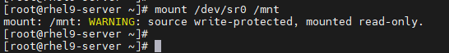

2. Verify it using df -Th command-

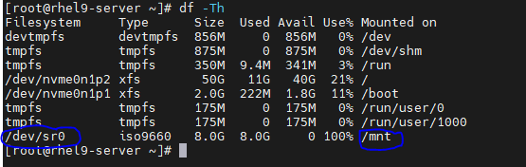

3. Move existing repository from /etc/yum.repos.d to /tmp-



4. Create directory /local_repo to copy mounted dvd contents-



5. Create local repository file in /etc/yum.repos.d with extension .repo-



6. Copy the dvd content from /mnt to /local_repo-



7. Enter repository details in local repository file in /etc/yum.repos.d/local.repo-



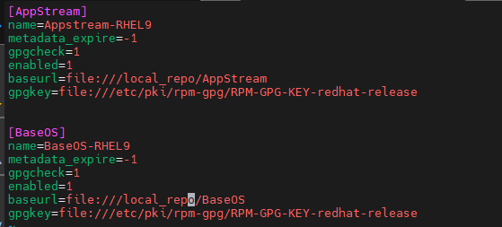

8. Cleanup temporary repository files-



9. Disable Redhat subscription warning-



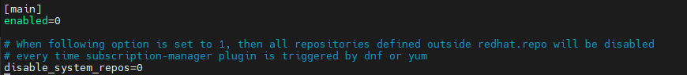

Make enabled=0

10. Run yum repolist command to check whether it is working or not-



11. Try with installing a package using yum install. Ex-httpd packages as shown below-



This is it!!!!!